Hands-On Cooking Classes
Agriturismo Luna di Quarazzana
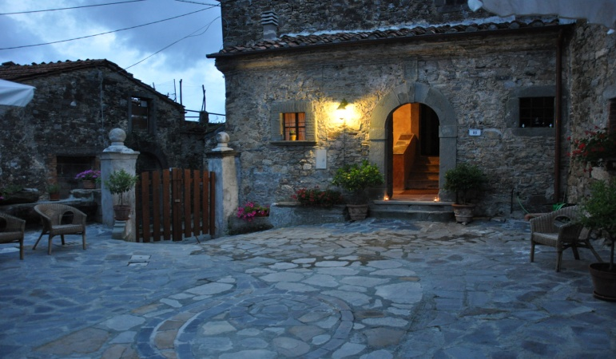

Our Agriturismo is located in a tiny rural Hamlet overlooking the Alpi Apuane where the time seems to stay still.
I am Ilaria, I grew up in a Florentine family, my grandmother, now 96, had a “trattoria” and she passed down to me her passion for cooking and the importance of choosing the best ingredients.
You’ll learn how to make the PASTA and discover the taste of country life (vita del contadino) at its simple Go Slow best.
I speak English and will fill you up with great food and gioia di vivere (the joy of living).
About our “Hands On” Cooking Classes
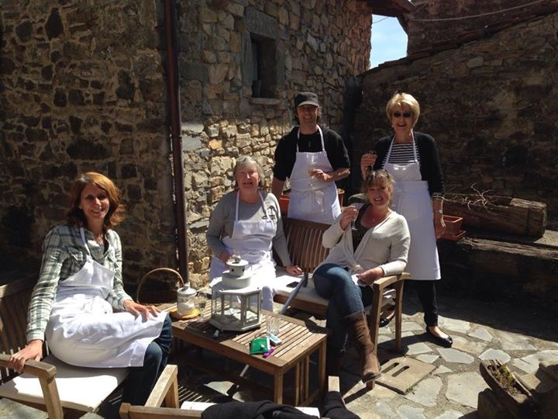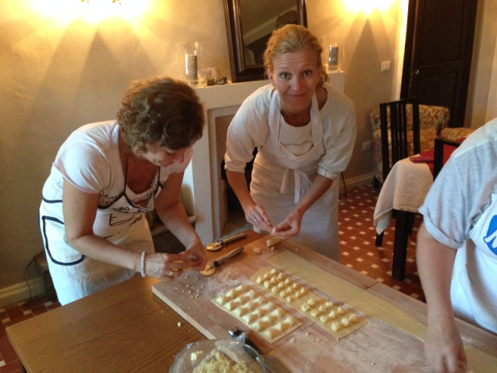
The class is held in my kitchen located in an ancient building in the heart of North-Tuscan country side.
All ingredients are our own organic products or bred by local farmers.
The course introduces participants to learn how to make the PASTA
Some exemple : Pasta fresca, Ravioli, tagliatelle, gnocchi, allowing you to prepare the dishes in your own home.
You’ll cook in the kitchen of the family in a relaxed, practical and friendly atmosphere .
The course lasts about two hours, followed by lunch.
RATES
Ask us about the rates: lalunadiquarazzana@gmail.com
CONDITIONS
The lesson include ingredients and lunch with Tuscan wines. These courses are available from April 1st to November 30th, and they are subject to availability. The number of places is limited. Hours: from 11:30 am
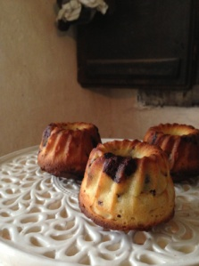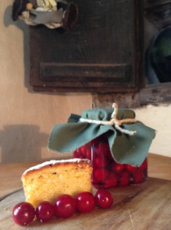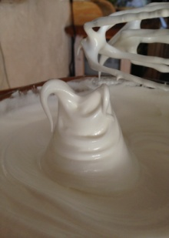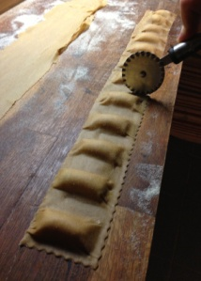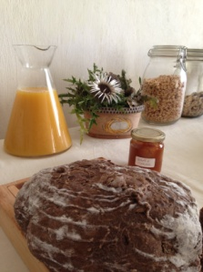
LOCATION
We are 8 km from Fivizzano:
From Piazza Medicea take the road SP17 for Pognana and continue in SP41 for Cotto, Panigaletto and Quarazzana. When you find the sign Quarazzana continue on the road about 127 mt on your left you’ll find a wood gate. Park there.
How to arrive:
https://goo.gl/maps/YL4nsemfiEy
A private driver can be arranged on request for pick-up and drop-off (not included IN PRICE)
Luna di Quarazzana
Via Nardi 16 – Quarazzana – Fivizzano 54013 Ms
www.Quarazzana.it
lalunadiquarazzana@gmail.com
lunadiquarazzana https://www.facebook.com/lunadiquarazzana/

